TO THE GOOD DOCTORS IN MOUNT ELIZABETH NOVENA HOSPITAL
On 14 April 2026, I underwent hip-replacement surgery at Mount Elizabeth Novena Hospital in Singapore. It is difficult to fully express in words what this experience meant to me—but it was truly exceptional in every sense.
The surgery itself went extremely well, and I feel deeply fortunate to have been in the hands of Dr. Kau Chung Yuan. He is, without exaggeration, a world-class surgeon—highly skilled, calm, and precise. But beyond his expertise, what stands out is the sense of trust and confidence he gives his patients. I would recommend him without hesitation.

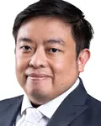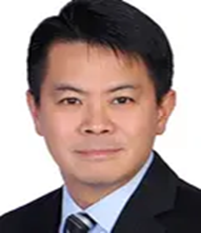
Dr. Kau Chung Yuan/Dr Tan Chen Lung Daryl/Dr Chua Yu Kim Dennis/ Dr Ng Kok Heong Alvin/ Dr Lee Rui Min
What made this experience even more remarkable was the extraordinary team surrounding him. My anesthetist, Dr. Lee, my kidney specialist, Dr. Alvin, my ENT specialist, Dr. Dennis Chua, and my hematologist, Dr. Daryl Tan—each of them is an outstanding expert in their field. Yet what truly sets them apart is not only their knowledge, but their dedication, attentiveness, and genuine care. You feel seen, understood, and safe at every moment.
I have been treated in hospitals in the United States and in Germany, but I can honestly say that I have never experienced anything comparable to the level of medical excellence and service at Mount Elizabeth Novena. The quality of care goes far beyond professionalism—it feels almost personal, almost human in a way that is rare in modern medicine. It is, quite simply, on another level.
I am deeply grateful—to Dr. Kau, Dr. Lee, Dr. Alvin, Dr. Dennis Chua, Dr. Daryl Tan, and the entire team. Thank you not only for your expertise, but for your humanity.
For anyone considering surgery, I can only say this: you could not be in better hands than at Mount Elizabeth Novena Hospital in Singapore.

Best regards,

Dr. Oliver Massmann

